GitHub Repository

Step 1: Create new repository into GitHub.

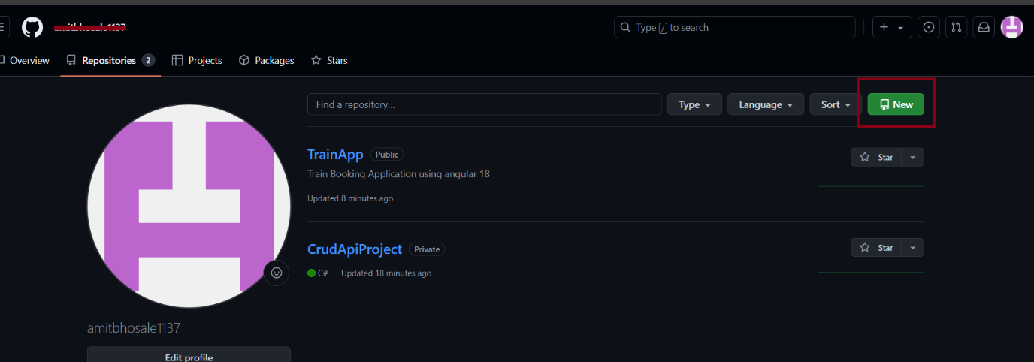

Add Repository Name

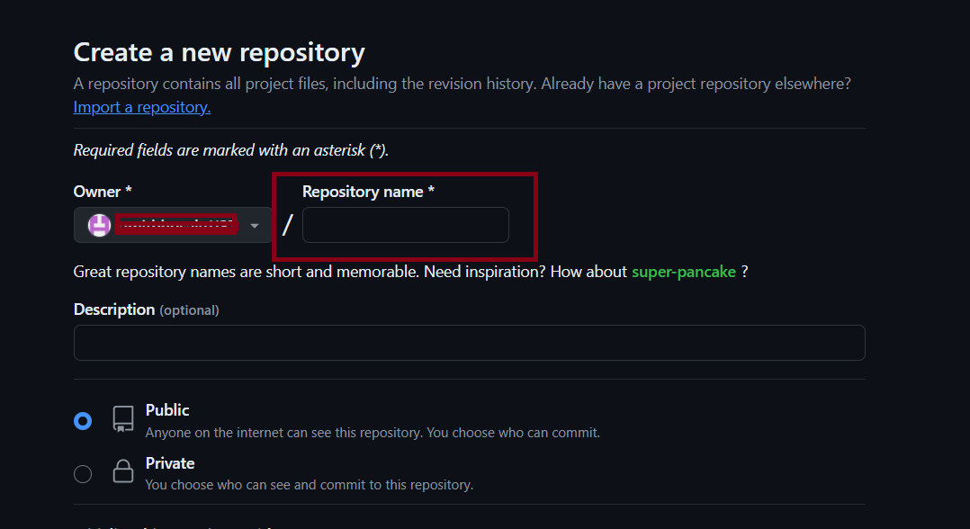

Step 2:

* git clone https://github.com/amitbhosale1137/EmployeeManagement.git

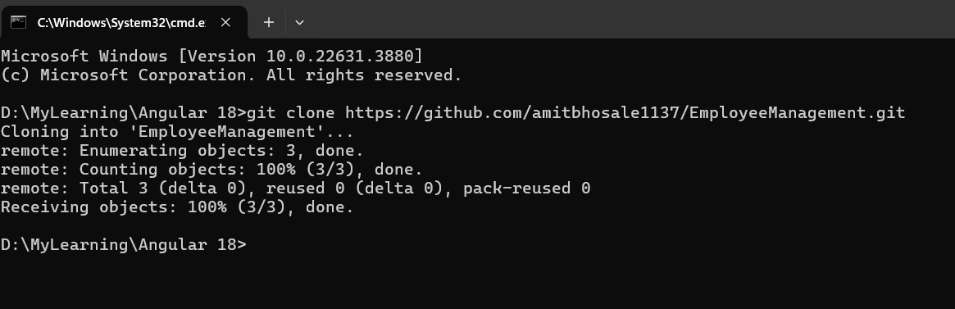

Step 3: Open Project folder

* ng add angular-cli-ghpages
* PS D:\MyLearning\Angular 18\EmployeeManagement> ng add angular-cli-ghpages

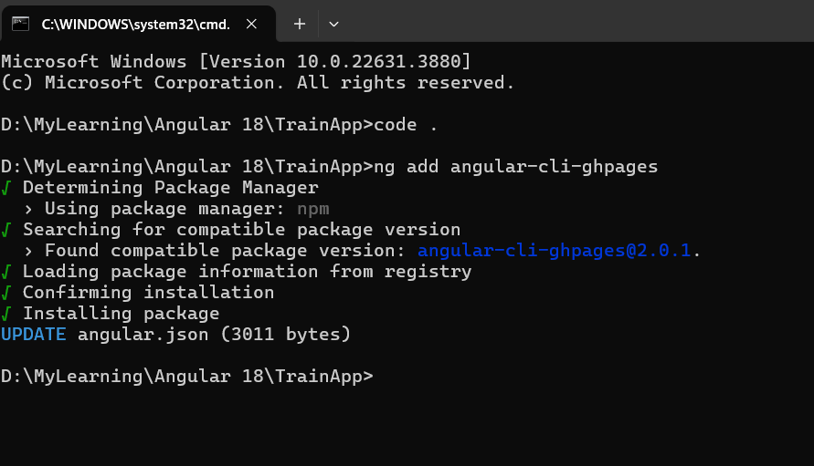

Open package.json file new line will be added see below image

Angular-cli-ghpages

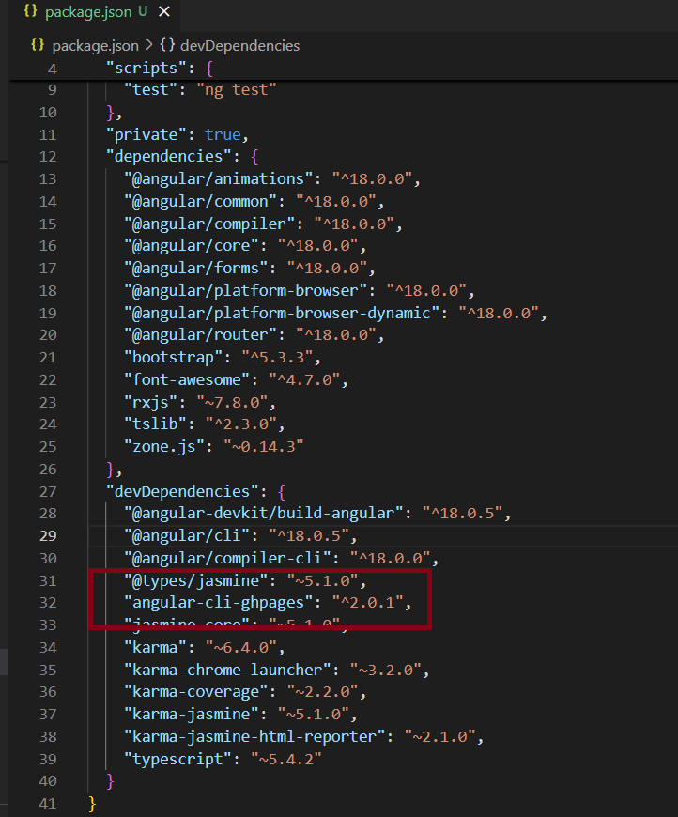

Step 3: Go to GitHub account select repository -> setting -> pages -> Deploy from a branch

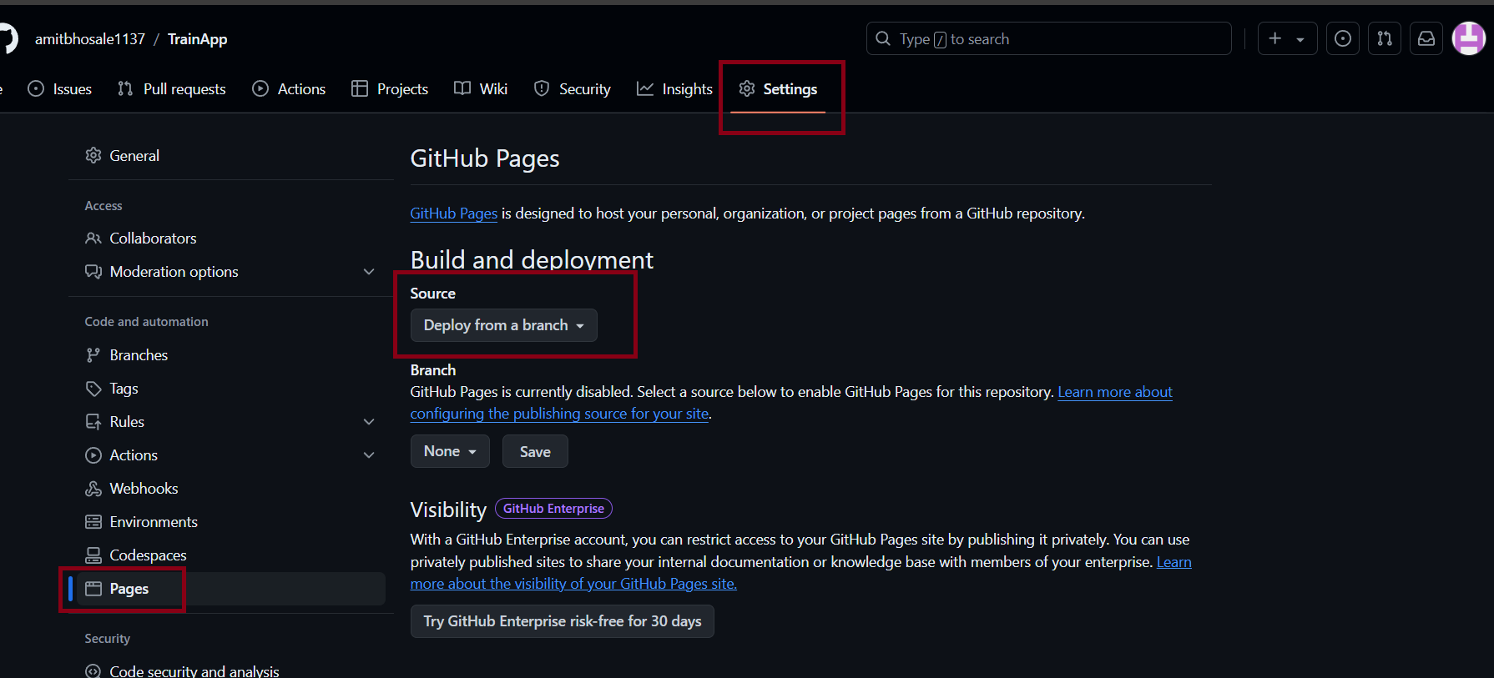

Step 4: check the git status

* git status
* PS D:\MyLearning\Angular 18\EmployeeManagement> git status

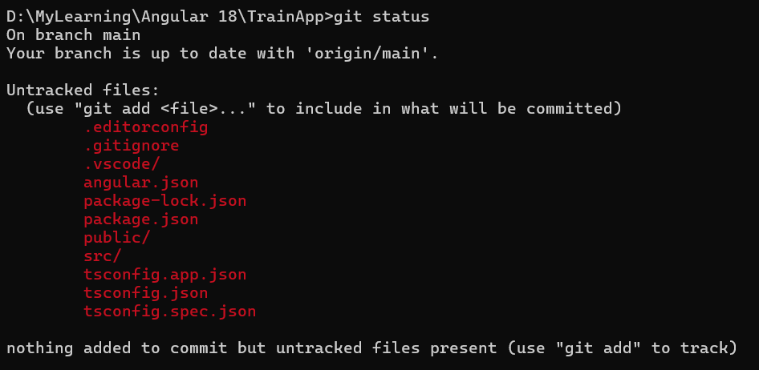

Step 5: Push all code into repository

* git add .
* PS D:\MyLearning\Angular 18\EmployeeManagement> git add .

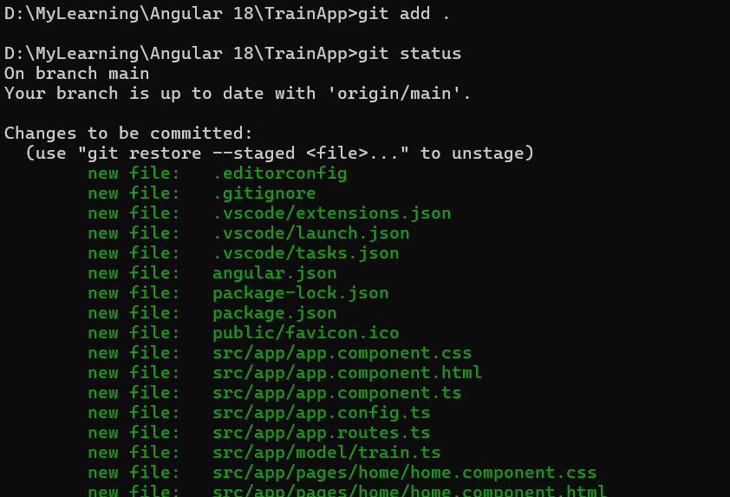

Step 6: Commit the code

* git commit -m “Initial Project Commit”
* PS D:\MyLearning\Angular 18\EmployeeManagement> git commit -m "Initial Project Commit"

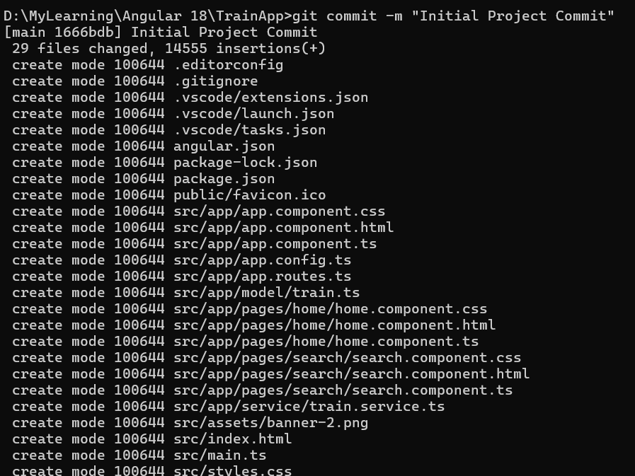

Step 7: Push the changes

* git push
* PS D:\MyLearning\Angular 18\EmployeeManagement> git push

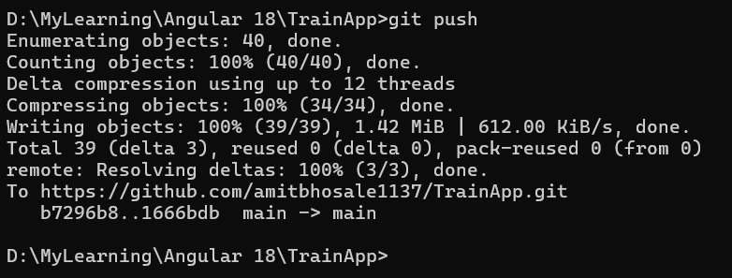

Step 8: Go to repo setting and select branch and save

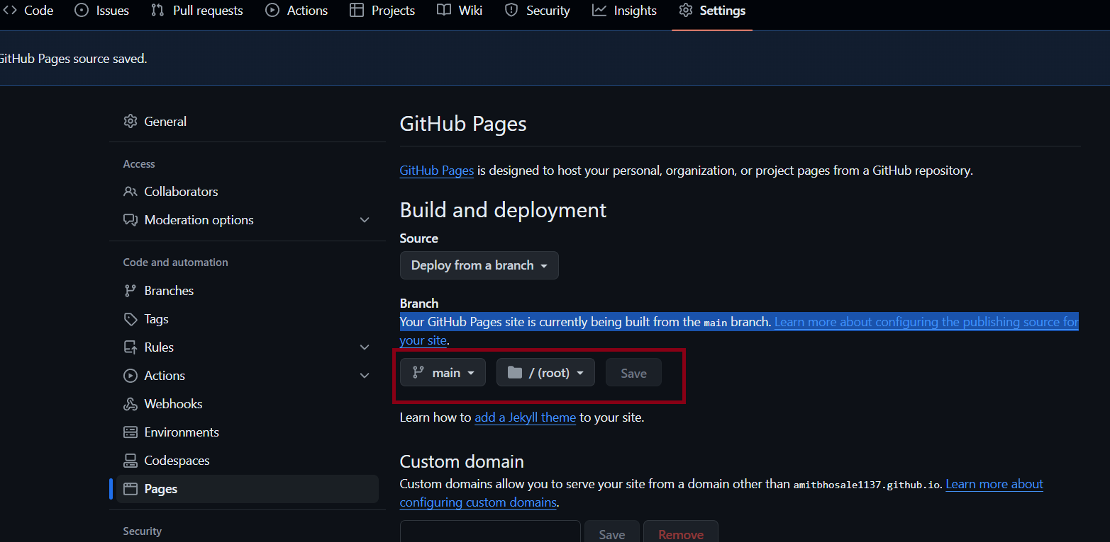

Step 9: Build application using below command

* ng build --base-href <https://amitbhosale1137.github.io/TrainApp>

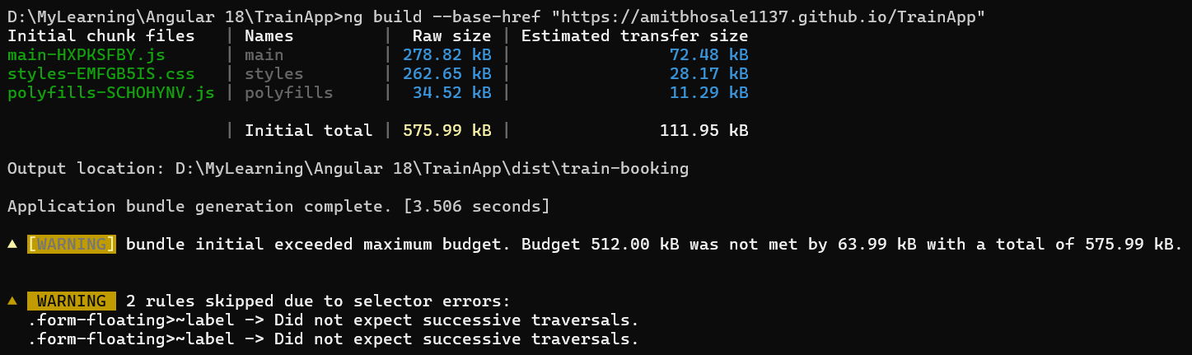

Step 10:

npx angular-cli-ghpages --dir=dist/train-booking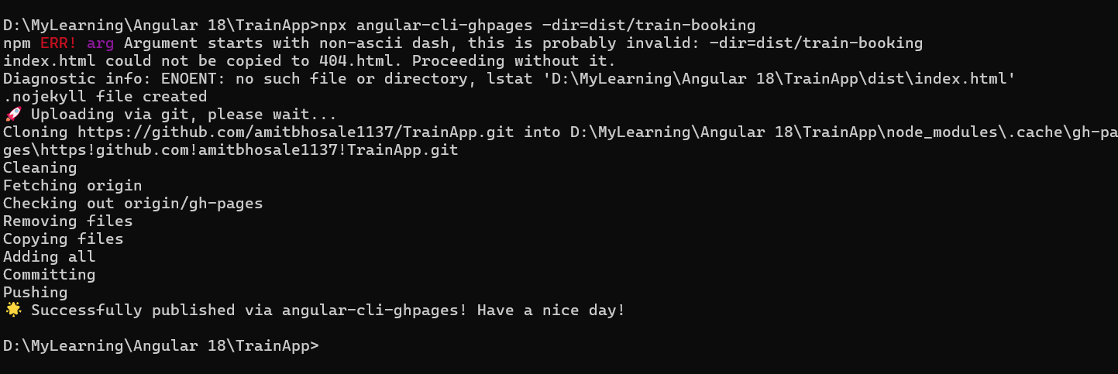

Step 11: Go to repo setting and select gh-pages and save

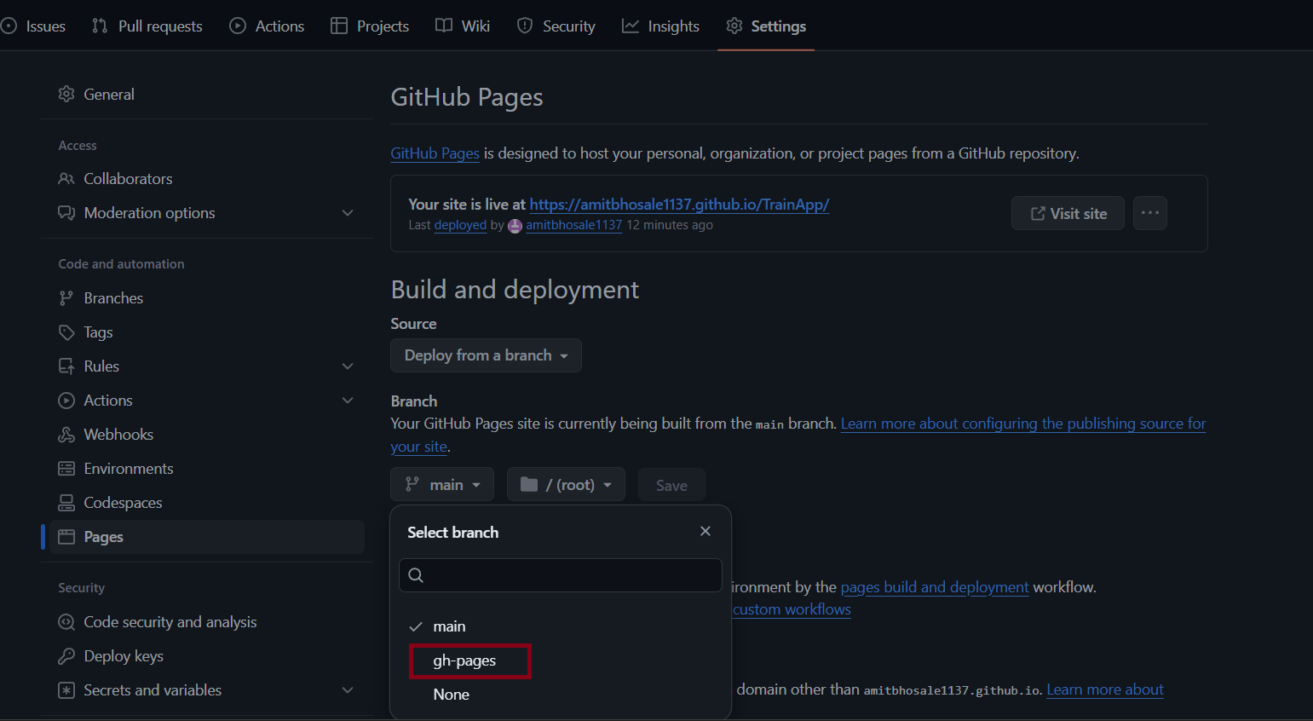

Step 12: open <https://amitbhosale1137.github.io/TrainApp> URL

<https://amitbhosale1137.github.io/employeemanagement>

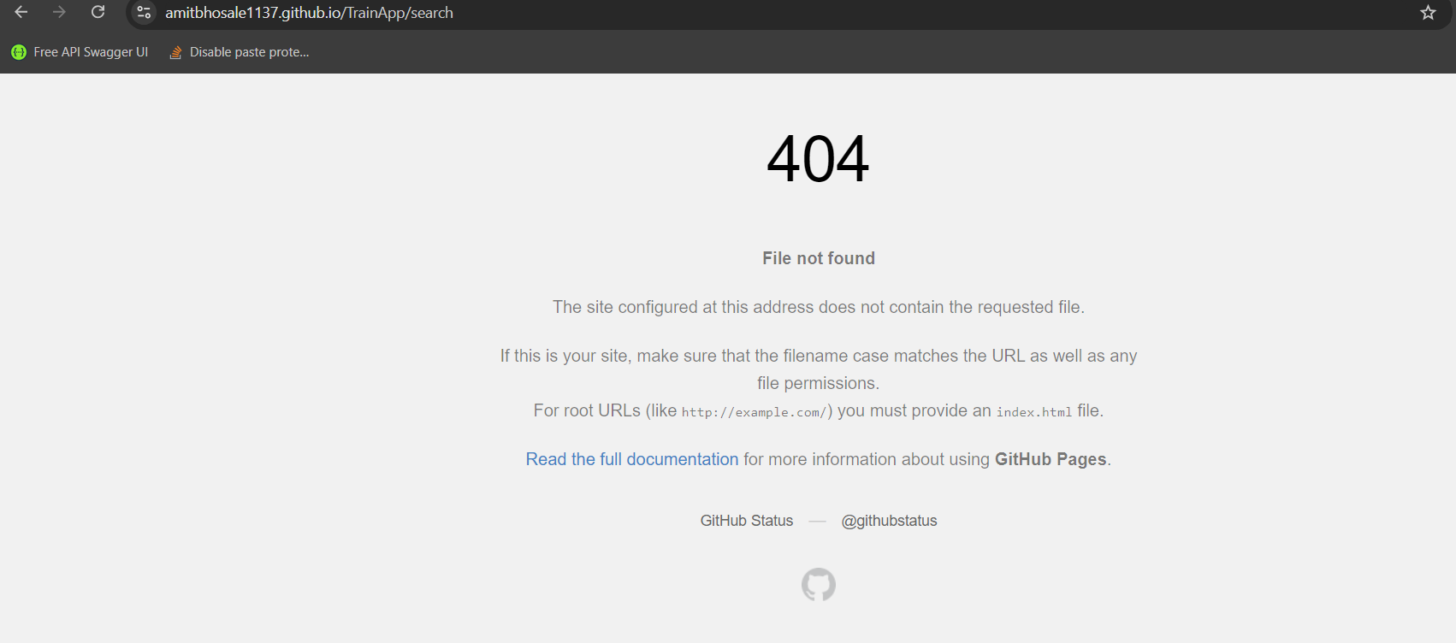

Step 13: npm install -g appium

Git New Steps

ng new demo

* PS D:\MyLearning\Angular 18\demo> git init

Reinitialized existing Git repository in D:/MyLearning/Angular 18/demo/.git/

* PS D:\MyLearning\Angular 18\demo> git commit -m "first commit"

On branch master

Changes not staged for commit:

(use "git add <file>..." to update what will be committed)

(use "git restore <file>..." to discard changes in working directory)

modified: angular.json

modified: src/app/app.component.html

no changes added to commit (use "git add" and/or "git commit -a")

* PS D:\MyLearning\Angular 18\demo> git add .
* PS D:\MyLearning\Angular 18\demo> git commit -m "first commit"

[master cd080cd] first commit

2 files changed, 5 insertions(+), 336 deletions(-)

* PS D:\MyLearning\Angular 18\demo> git branch -M main
* PS D:\MyLearning\Angular 18\demo> git remote add origin <https://github.com/amitbhosale1137/demo.git>
* PS D:\MyLearning\Angular 18\demo> git push -u origin main

Enumerating objects: 34, done.

Counting objects: 100% (34/34), done.

Delta compression using up to 12 threads

Compressing objects: 100% (31/31), done.

Writing objects: 100% (34/34), 124.35 KiB | 3.89 MiB/s, done.

Total 34 (delta 4), reused 0 (delta 0), pack-reused 0 (from 0)

remote: Resolving deltas: 100% (4/4), done.

To https://github.com/amitbhosale1137/demo.git

\* [new branch] main -> main

branch 'main' set up to track 'origin/main'.

* PS D:\MyLearning\Angular 18\demo> ng b --output-path docs --base-href=/demo/

Initial chunk files | Names | Raw size | Estimated transfer size

main-R3AJQH2H.js | main | 177.40 kB | 47.65 kB

polyfills-SCHOHYNV.js | polyfills | 34.52 kB | 11.29 kB

styles-5INURTSO.css | styles | 0 bytes | 0 bytes

| Initial total | 211.93 kB | 58.94 kB

Output location: D:\MyLearning\Angular 18\demo\docs

Application bundle generation complete. [7.568 seconds]

* PS D:\MyLearning\Angular 18\demo> git add .

warning: in the working copy of 'docs/3rdpartylicenses.txt', LF will be replaced by CRLF the next time Git touches it

warning: in the working copy of 'docs/browser/main-R3AJQH2H.js', LF will be replaced by CRLF the next time Git touches it

warning: in the working copy of 'docs/browser/polyfills-SCHOHYNV.js', LF will be replaced by CRLF the next time Git touches it

* PS D:\MyLearning\Angular 18\demo> git commit -m "First commit"

[main 480d22a] First commit

6 files changed, 293 insertions(+)

create mode 100644 docs/3rdpartylicenses.txt

create mode 100644 docs/browser/favicon.ico

create mode 100644 docs/browser/index.html

create mode 100644 docs/browser/main-R3AJQH2H.js

create mode 100644 docs/browser/polyfills-SCHOHYNV.js

create mode 100644 docs/browser/styles-5INURTSO.css

* PS D:\MyLearning\Angular 18\demo> git push

Enumerating objects: 11, done.

Counting objects: 100% (11/11), done.

Delta compression using up to 12 threads

Compressing objects: 100% (9/9), done.

Writing objects: 100% (10/10), 73.66 KiB | 3.51 MiB/s, done.

Total 10 (delta 1), reused 0 (delta 0), pack-reused 0 (from 0)

remote: Resolving deltas: 100% (1/1), completed with 1 local object.

To https://github.com/amitbhosale1137/demo.git

cd080cd..480d22a main -> main

* PS D:\MyLearning\Angular 18\demo>

Copy all file from browser folder and paste into doc folder

* PS D:\MyLearning\Angular 18\demo> git add .

warning: in the working copy of 'docs/3rdpartylicenses.txt', LF will be replaced by CRLF the next time Git touches it

warning: in the working copy of 'docs/browser/main-R3AJQH2H.js', LF will be replaced by CRLF the next time Git touches it

warning: in the working copy of 'docs/browser/polyfills-SCHOHYNV.js', LF will be replaced by CRLF the next time Git touches it

* PS D:\MyLearning\Angular 18\demo> git commit -m "First commit"

[main 480d22a] First commit

6 files changed, 293 insertions(+)

create mode 100644 docs/3rdpartylicenses.txt

create mode 100644 docs/browser/favicon.ico

create mode 100644 docs/browser/index.html

create mode 100644 docs/browser/main-R3AJQH2H.js

create mode 100644 docs/browser/polyfills-SCHOHYNV.js

create mode 100644 docs/browser/styles-5INURTSO.css

* PS D:\MyLearning\Angular 18\demo> git push

Enumerating objects: 11, done.

Counting objects: 100% (11/11), done.

Delta compression using up to 12 threads

Compressing objects: 100% (9/9), done.

Writing objects: 100% (10/10), 73.66 KiB | 3.51 MiB/s, done.

Total 10 (delta 1), reused 0 (delta 0), pack-reused 0 (from 0)

remote: Resolving deltas: 100% (1/1), completed with 1 local object.

To https://github.com/amitbhosale1137/demo.git

cd080cd..480d22a main -> main

* PS D:\MyLearning\Angular 18\demo> ng b --output-path docs --base-href=/demo/

Initial chunk files | Names | Raw size | Estimated transfer size

main-R3AJQH2H.js | main | 177.40 kB | 47.65 kB

polyfills-SCHOHYNV.js | polyfills | 34.52 kB | 11.29 kB

styles-5INURTSO.css | styles | 0 bytes | 0 bytes

| Initial total | 211.93 kB | 58.94 kB

Output location: D:\MyLearning\Angular 18\demo\docs

Application bundle generation complete. [4.076 seconds]

* PS D:\MyLearning\Angular 18\demo> git status

On branch main

Your branch is up to date with 'origin/main'.

Untracked files:

(use "git add <file>..." to include in what will be committed)

docs/favicon.ico

docs/index.html

docs/main-R3AJQH2H.js

docs/polyfills-SCHOHYNV.js

docs/styles-5INURTSO.css

nothing added to commit but untracked files present (use "git add" to track)

* PS D:\MyLearning\Angular 18\demo> git add .

warning: in the working copy of 'docs/main-R3AJQH2H.js', LF will be replaced by CRLF the next time Git touches it

warning: in the working copy of 'docs/polyfills-SCHOHYNV.js', LF will be replaced by CRLF the next time Git touches it

* PS D:\MyLearning\Angular 18\demo> git commit -m "updated"

[main 8cbaa11] updated

5 files changed, 22 insertions(+)

create mode 100644 docs/favicon.ico

create mode 100644 docs/index.html

create mode 100644 docs/main-R3AJQH2H.js

create mode 100644 docs/polyfills-SCHOHYNV.js

create mode 100644 docs/styles-5INURTSO.css

* PS D:\MyLearning\Angular 18\demo> git push

Enumerating objects: 10, done.

Counting objects: 100% (10/10), done.

Delta compression using up to 12 threads

Compressing objects: 100% (7/7), done.

Writing objects: 100% (8/8), 68.99 KiB | 3.45 MiB/s, done.

Total 8 (delta 1), reused 0 (delta 0), pack-reused 0 (from 0)

remote: Resolving deltas: 100% (1/1), completed with 1 local object.

To https://github.com/amitbhosale1137/demo.git

480d22a..8cbaa11 main -> main

PS D:\MyLearning\Angular 18\demo>

Successfully done

PS D:\MyLearning\Angular 18\EmployeeManagement> git init

Reinitialized existing Git repository in D:/MyLearning/Angular 18/EmployeeManagement/.git/

PS D:\MyLearning\Angular 18\EmployeeManagement> git commit -m "first commit"

On branch main

Your branch is up to date with 'origin/main'.

nothing to commit, working tree clean

PS D:\MyLearning\Angular 18\EmployeeManagement> git add .

PS D:\MyLearning\Angular 18\EmployeeManagement> git branch -M main

PS D:\MyLearning\Angular 18\EmployeeManagement> git remote add origin

usage: git remote add [<options>] <name> <url>

-f, --[no-]fetch fetch the remote branches

--[no-]tags import all tags and associated objects when fetching

or do not fetch any tag at all (--no-tags)

-t, --[no-]track <branch>

branch(es) to track

-m, --[no-]master <branch>

master branch

--[no-]mirror[=(push|fetch)]

set up remote as a mirror to push to or fetch from

PS D:\MyLearning\Angular 18\EmployeeManagement> git remote add origin https://github.com/amitbhosale1137/EmployeeManagement.git

error: remote origin already exists.

PS D:\MyLearning\Angular 18\EmployeeManagement> git push -u origin main

branch 'main' set up to track 'origin/main'.

Everything up-to-date

PS D:\MyLearning\Angular 18\EmployeeManagement> ng b --output-path docs --base-href=/EmployeeManagement/

Initial chunk files | Names | Raw size | Estimated transfer size

main-XFLY4VWC.js | main | 179.38 kB | 48.30 kB

polyfills-SCHOHYNV.js | polyfills | 34.52 kB | 11.29 kB

styles-FXC3PVXH.css | styles | 39 bytes | 39 bytes

| Initial total | 213.95 kB | 59.62 kB

Output location: D:\MyLearning\Angular 18\EmployeeManagement\docs

Application bundle generation complete. [4.078 seconds]

PS D:\MyLearning\Angular 18\EmployeeManagement> git add .

warning: in the working copy of 'docs/3rdpartylicenses.txt', LF will be replaced by CRLF the next time Git touches it

warning: in the working copy of 'docs/browser/main-XFLY4VWC.js', LF will be replaced by CRLF the next time Git touches it

warning: in the working copy of 'docs/browser/polyfills-SCHOHYNV.js', LF will be replaced by CRLF the next time Git touches it

warning: in the working copy of 'docs/browser/styles-FXC3PVXH.css', LF will be replaced by CRLF the next time Git touches it

PS D:\MyLearning\Angular 18\EmployeeManagement> git commit -m "third commit"

[main 54bc259] third commit

6 files changed, 295 insertions(+)

create mode 100644 docs/3rdpartylicenses.txt

create mode 100644 docs/browser/favicon.ico

create mode 100644 docs/browser/index.html

create mode 100644 docs/browser/main-XFLY4VWC.js

create mode 100644 docs/browser/polyfills-SCHOHYNV.js

create mode 100644 docs/browser/styles-FXC3PVXH.css

PS D:\MyLearning\Angular 18\EmployeeManagement> git push

Enumerating objects: 11, done.

Counting objects: 100% (11/11), done.

Delta compression using up to 12 threads

Compressing objects: 100% (9/9), done.

Writing objects: 100% (10/10), 74.54 KiB | 3.73 MiB/s, done.

Total 10 (delta 1), reused 0 (delta 0), pack-reused 0 (from 0)

remote: Resolving deltas: 100% (1/1), completed with 1 local object.

To https://github.com/amitbhosale1137/EmployeeManagement.git

15e4ee1..54bc259 main -> main

PS D:\MyLearning\Angular 18\EmployeeManagement> > git add .

> : The term '>' is not recognized as the name of a cmdlet, function, script file, or operable program. Check the spelling of

the name, or if a path was included, verify that the path is correct and try again.

At line:1 char:1

+ > git add .

+ ~

+ CategoryInfo : ObjectNotFound: (>:String) [], CommandNotFoundException

+ FullyQualifiedErrorId : CommandNotFoundException

PS D:\MyLearning\Angular 18\EmployeeManagement> git add .

warning: in the working copy of 'docs/main-XFLY4VWC.js', LF will be replaced by CRLF the next time Git touches it

warning: in the working copy of 'docs/polyfills-SCHOHYNV.js', LF will be replaced by CRLF the next time Git touches it

warning: in the working copy of 'docs/styles-FXC3PVXH.css', LF will be replaced by CRLF the next time Git touches it

PS D:\MyLearning\Angular 18\EmployeeManagement> git commit -m "fourth commit"

[main 7cab66f] fourth commit

5 files changed, 24 insertions(+)

create mode 100644 docs/favicon.ico

create mode 100644 docs/index.html

create mode 100644 docs/main-XFLY4VWC.js

create mode 100644 docs/polyfills-SCHOHYNV.js

create mode 100644 docs/styles-FXC3PVXH.css

PS D:\MyLearning\Angular 18\EmployeeManagement> git push

Enumerating objects: 10, done.

Counting objects: 100% (10/10), done.

Delta compression using up to 12 threads

Compressing objects: 100% (7/7), done.

Writing objects: 100% (8/8), 69.88 KiB | 3.88 MiB/s, done.

Total 8 (delta 1), reused 0 (delta 0), pack-reused 0 (from 0)

remote: Resolving deltas: 100% (1/1), completed with 1 local object.

To https://github.com/amitbhosale1137/EmployeeManagement.git

54bc259..7cab66f main -> main

PS D:\MyLearning\Angular 18\EmployeeManagement> ng b --output-path docs --base-href=/employeemanagement/

Initial chunk files | Names | Raw size | Estimated transfer size

main-XFLY4VWC.js | main | 179.38 kB | 48.30 kB

polyfills-SCHOHYNV.js | polyfills | 34.52 kB | 11.29 kB

styles-FXC3PVXH.css | styles | 39 bytes | 39 bytes

| Initial total | 213.95 kB | 59.62 kB

Output location: D:\MyLearning\Angular 18\EmployeeManagement\docs

Application bundle generation complete. [4.017 seconds]

PS D:\MyLearning\Angular 18\EmployeeManagement> git status

On branch main

Your branch is up to date with 'origin/main'.

Changes not staged for commit:

(use "git add/rm <file>..." to update what will be committed)

(use "git restore <file>..." to discard changes in working directory)

modified: docs/browser/index.html

deleted: docs/favicon.ico

deleted: docs/index.html

deleted: docs/main-XFLY4VWC.js

deleted: docs/polyfills-SCHOHYNV.js

deleted: docs/styles-FXC3PVXH.css

no changes added to commit (use "git add" and/or "git commit -a")

PS D:\MyLearning\Angular 18\EmployeeManagement> git add .

PS D:\MyLearning\Angular 18\EmployeeManagement> git commit -m "updated"

[main 35e12f6] updated

6 files changed, 1 insertion(+), 25 deletions(-)

delete mode 100644 docs/favicon.ico

delete mode 100644 docs/index.html

delete mode 100644 docs/main-XFLY4VWC.js

delete mode 100644 docs/polyfills-SCHOHYNV.js

delete mode 100644 docs/styles-FXC3PVXH.css

PS D:\MyLearning\Angular 18\EmployeeManagement> git push

Enumerating objects: 9, done.

Counting objects: 100% (9/9), done.

Delta compression using up to 12 threads

Compressing objects: 100% (5/5), done.

Writing objects: 100% (5/5), 451 bytes | 225.00 KiB/s, done.

Total 5 (delta 3), reused 0 (delta 0), pack-reused 0 (from 0)

remote: Resolving deltas: 100% (3/3), completed with 3 local objects.

remote: This repository moved. Please use the new location:

remote: https://github.com/amitbhosale1137/employeemanagement.git

To https://github.com/amitbhosale1137/EmployeeManagement.git

7cab66f..35e12f6 main -> main

PS D:\MyLearning\Angular 18\EmployeeManagement> ng b --output-path docs --base-href=/employeemanagement/

Initial chunk files | Names | Raw size | Estimated transfer size

main-XFLY4VWC.js | main | 179.38 kB | 48.30 kB

polyfills-SCHOHYNV.js | polyfills | 34.52 kB | 11.29 kB

styles-FXC3PVXH.css | styles | 39 bytes | 39 bytes

| Initial total | 213.95 kB | 59.62 kB

Output location: D:\MyLearning\Angular 18\EmployeeManagement\docs

Application bundle generation complete. [4.407 seconds]

PS D:\MyLearning\Angular 18\EmployeeManagement> git status

On branch main

Your branch is up to date with 'origin/main'.

nothing to commit, working tree clean

PS D:\MyLearning\Angular 18\EmployeeManagement> git status

On branch main

Your branch is up to date with 'origin/main'.

Untracked files:

(use "git add <file>..." to include in what will be committed)

docs/favicon.ico

docs/index.html

docs/main-XFLY4VWC.js

docs/polyfills-SCHOHYNV.js

docs/styles-FXC3PVXH.css

nothing added to commit but untracked files present (use "git add" to track)

PS D:\MyLearning\Angular 18\EmployeeManagement> git add .

warning: in the working copy of 'docs/main-XFLY4VWC.js', LF will be replaced by CRLF the next time Git touches it

warning: in the working copy of 'docs/polyfills-SCHOHYNV.js', LF will be replaced by CRLF the next time Git touches it

warning: in the working copy of 'docs/styles-FXC3PVXH.css', LF will be replaced by CRLF the next time Git touches it

PS D:\MyLearning\Angular 18\EmployeeManagement> git commit -m " commit"

[main 95f5bcc] commit

5 files changed, 24 insertions(+)

create mode 100644 docs/favicon.ico

create mode 100644 docs/index.html

create mode 100644 docs/main-XFLY4VWC.js

create mode 100644 docs/polyfills-SCHOHYNV.js

create mode 100644 docs/styles-FXC3PVXH.css

PS D:\MyLearning\Angular 18\EmployeeManagement> git push

Enumerating objects: 10, done.

Counting objects: 100% (10/10), done.

Delta compression using up to 12 threads

Compressing objects: 100% (7/7), done.

Writing objects: 100% (8/8), 69.88 KiB | 3.33 MiB/s, done.

Total 8 (delta 1), reused 0 (delta 0), pack-reused 0 (from 0)

remote: Resolving deltas: 100% (1/1), completed with 1 local object.

remote: This repository moved. Please use the new location:

remote: https://github.com/amitbhosale1137/employeemanagement.git

To https://github.com/amitbhosale1137/EmployeeManagement.git

35e12f6..95f5bcc main -> main

PS D:\MyLearning\Angular 18\EmployeeManagement>